Go to <http://wiki.csusb.edu>

* Log in

Teacher said:

The award’s given to these books have color in the back ground and they are easy reader’s which is not the usual criteria for an easy reader.

**Theodor Seuss Geisel Award**

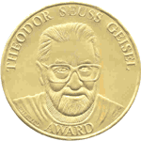

The Theodor Seuss Geisel Award is given annually to the author(s) and illustrator(s) of the most distinguished American book for beginning readers published in English in the United States during the preceding year.   The winner(s), recognized for their literary and artistic achievements that demonstrate creativity and imagination to engage children in reading, receives a bronze medal.  Honor Book authors and illustrators receive certificates, which are presented at the ALA Annual Conference.  The award was established in 2004 and first presented in 2006.

The award is named for the world-renowned children’s author, Theodor Geisel. "A person’s a person no matter how small," Theodor Geisel, a.k.a. Dr. Seuss, would say. "Children want the same things we want: to laugh, to be challenged, to be entertained and delighted." Brilliant, playful, and always respectful of children, Dr. Seuss charmed his way into the consciousness of four generations of youngsters and parents. In the process, he helped them to read.

<http://www.ala.org/ala/mgrps/divs/alsc/awardsgrants/bookmedia/geiselaward/index.cfm>

**Color and Line:**

The use of color and line is commonly used throughout these books to help the book achieve its goal.

**2006 Medal Winner**

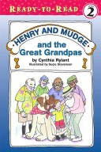

**Henry and Mudge and the Great Grandpas** written by Cynthia Rylant and illustrated by Suçie Stevenson

Henry and his family go to visit his great grandfather at a retirement home one summer day. That day Henry and the great grandpas set out for a fun summer day.

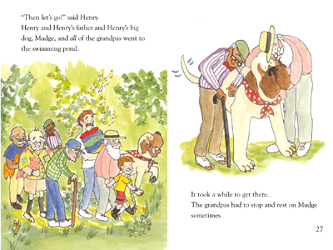

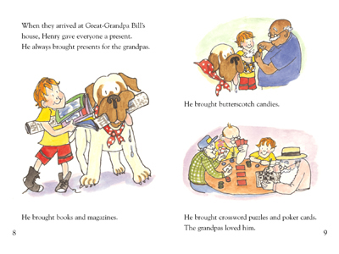

**2006 Honor Book**

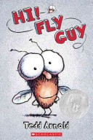

**Hi! Fly Guy** by Tedd Arnold

A boy in search of a pet to enter into a contest finds himself a fly with lots of personality.

The colors used for *Hi! Fly Guy* are soft bright and child like. The yellows, light blues and soft reds give this book a light and casual feeling. The lines used through out this book are round, or some form of circular shape. This helps the book give it a sense of comfort and casualness. This book’s goal was to make the reader feel comfortable and cheery and it achieved it through both the colors and the method of line.

**2006 Honor Book**

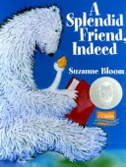

**A Splendid Friend, Indeed**

A diligent polar bear try’s to read, write and think silently while a very energetic goose try’s to capture his attention.

Another example of how the author used color to achieve the feeling of the book is A Friend, Indeed. The author used to color to create the mood the polar bear was feeling. A direct example of this can been seen from the color of the background pages. The pages start off dark blue then with every turn of the page the dark blue transitions into a lighter blue. The transition of color helps the book evoke emotions that the polar bear feels of seriousness and irritation in the beginning to accepting and understanding towards the end.

**2006 Honor Book**

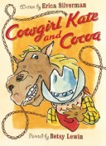

**Cowgirl Kate and Cocoa** written by Erica Silverman and illustrated by Betsy Lewin

Cowgirl Kate and her hungry horse Cocoa share each others company out on the farm.

In the beginning of this book the author uses the neutral colors of nature like, brown, tan, green, yellow and gray to show how cowgirl Kate and her horse Cocoa are the out doors kind of friends. The only type of bright color is emphasized in cowgirl Kates red scarf and boots. The use of bright red on cowgirl Kate is to show how she is still a young girl who is fun and likes adventure. In the last chapter of the book blue is used for all of the pages. Cowgirl Kate and Cocoa are getting ready to fall asleep and the book is drawing to a close. The use of blue in the last chapter evokes a peaceful and safe feeling. The goal of this book was to help the reader figure out that Cocoa, although a massive animal, protects and cares for her owner and friend cowgirl Kate.

<http://books.google.com/books?id=XLfXCxjs-vkC&printsec=frontcover&dq=Cowgirl+Kate+and+Cocoa#PPT16,M1>

**First the Egg** written by Laura Vaccaro Seeger

In an unrelated series of pictures one event happens after another .

**Hello, Bumblebee Bat** written by Darrin Lunde

In Hello, Bumblebee Bat the use of dark blues throughout the whole book gives the sense of the bat traveling at night. On one of the pages the use of bright red and orange emphasizes the danger and fear that the bat has for fire. Another criteria used on that same page is line, the sharp pointed edges of the fire flames, eagles wings, leaves, and even the bat it self is giving the sense of danger and fear.

A traveling bat named Bumblebee is answering a series of facts about himself.

**There is a Bird on your Head!** Written by Mo Willems

Piggie and Elephant are hanging out like any other day. Piggie then notices that birds are nesting on top of her friend Geralds’ head. When Gerald notices that birds are on his head he panics and turns to piggie for help.

**Jazz Baby** Written by Lisa Wheeler

A rhythmic family that enjoys making music lyrics inside a home have a baby that also joins in on the rhythms’.